F R O G

Front Range Organic Gardeners, Inc.

Veteran and novice gardeners sharing knowledge
and enthusiasm since 1987.

www.gardenFROG.org
------------------------------------------------------------------------------------
September 2019 Volume 31, No. 9
------------------------------------------------------------------------------------
OUR NEXT MEETING -
India Small Acreage
Tuesday, September 24, 7:00pm
Corona Presbyterian Church, 1205 8th Avenue, Denver
(For location details, see page 7)

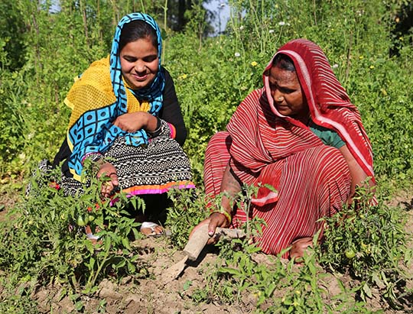
This presentation will include a quick tour of an agricultural international trip to India and Dubai. Highlights will focus on camel milk, a spice market, bee research, hydroponics, vegetable transplants, seed/rice production and other facts about agriculture in India and Dubai.

Speaker: Maria Bumgardener is a Soil Conservationist with the USDA Natural Resource Conservation Service and has a unique and rich family history in US farming. She has family roots farming before the American Revolutionary War to wheat farmers during the height of the dust bowl. Her experience from USDA NRCS includes forestry, noxious weeds and agriculture planning for landowners. Additionally, she has 10 years of experience in horticulture, design, irrigation and urban farming programming through the Denver Botanic Gardens. A graduate from the Colorado Agriculture Leadership Program, Maria is a certified arborist and board member of a local food coop which provides her with a diverse and unique background in agriculture.
3
Trish’s Notes ~
The morning sun comes up later, and the air is cool and fresh. Kids are back in school, and grocery stores are advertising lunch-box treats. The lazy days of summer have given way to the bustle of September.

Apples are on my mind. Back in Chicago, my mom loved to go out to an apple orchard, and we’d come home with a bushel of Golden Delicious, a jug of cider, jars of apple butter and jelly, and a pie for Sunday. The house smelled so good, and we had beautiful golden apples in our sack lunches. There’s an Apple Cider Festival in Lakewood in October that’s calling me.

It’s cornucopia time, with summer veggies still producing, and now the late-season crops of winter squashes, melons, and kohl plants coming in. Remember the food pantries if you have more than you can handle or give away. Use this link to find one near you – https://ampleharvest.org/find-pantry/ And you can still plant greens for late salads, or consider a cover crop.

September is also a great time for a clear-out, in your garden, in your home, and maybe in your life? What are you tired of, or just don’t want anymore? What is taking up more space, time, and energy than you want to give it? Dream about what you do want, imagine your garden/home/life as it could be, and clear out the things that stand in your way. Even if you don’t get to your end-goal right away, making room for it is a big step.

Which brings me to fall planting! Trees, shrubs, and perennials are perfect for settling in your garden in September, enjoying the mild weather in October, and gradually going dormant for winter. They’ll need compost, mulch, and water in winter, but really all our plantings do. And don’t forget to plant spring-blooming bulbs – the crocuses, daffodils, tulips, and other wonderful harbingers of Spring! Where to find plants? DBG has a plant sale in September, and check the garden centers, many of which have sales to lower inventory before winter.

Remember to enjoy the bounty! And I hope to see you at the September meeting.

Trish
President of FROG
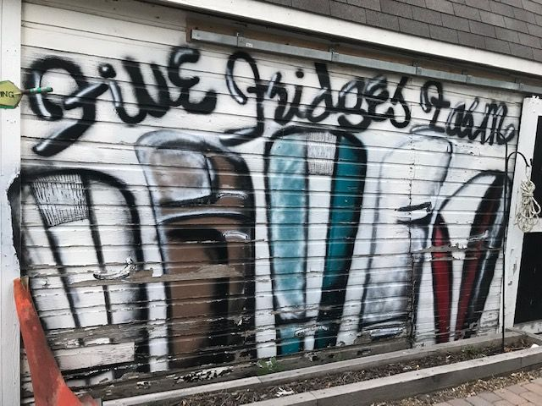
August Garden Tour –
Five Fridges Farm
The group enjoyed a beautiful summer evening at this urban farm surrounded by organic vegetables, goats and turkeys!

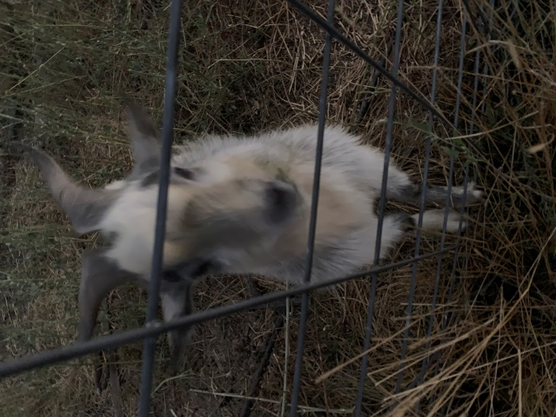

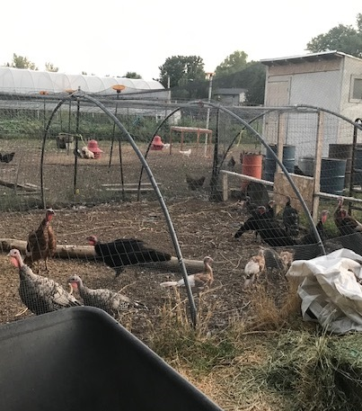

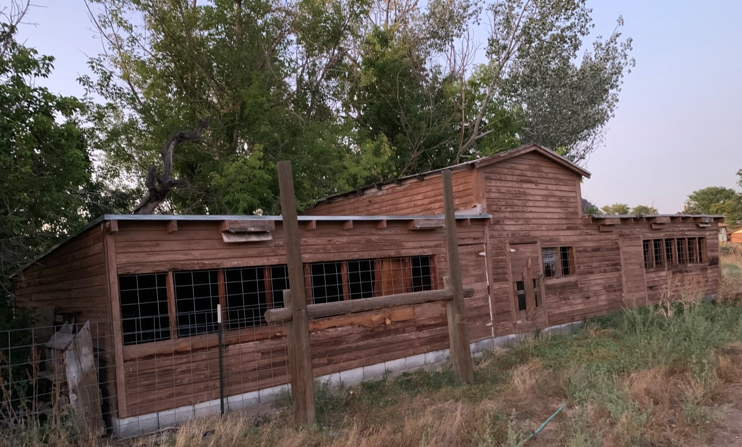

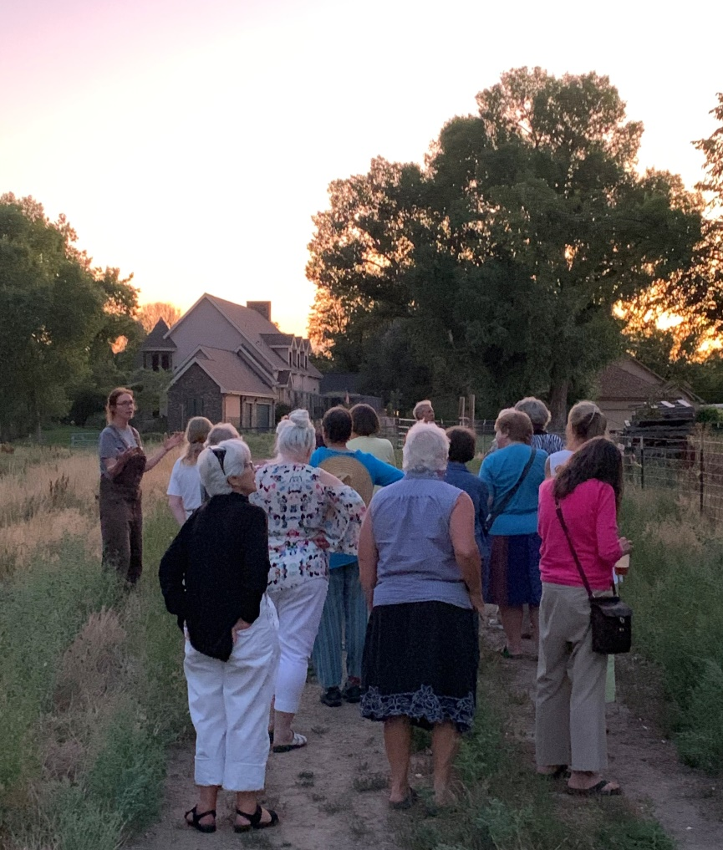

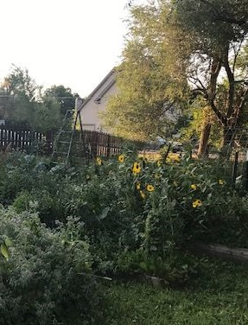
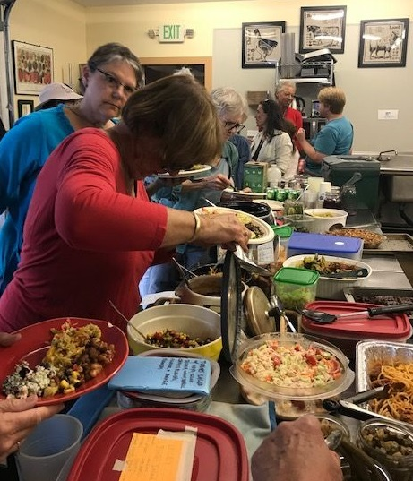
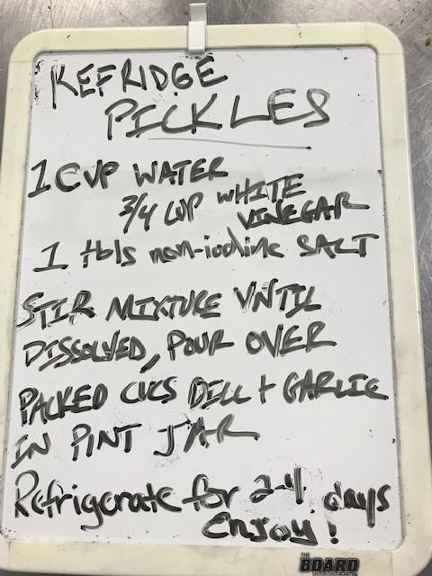

And, as always, the food and the company were wonderful!
Bounty: Contributed by FROG Members

By Marvel Hammer
How to Prune Overgrown Tomatoes in Late Summer
https://www.youtube.com/watch?v=lCPaEhDEuBc&feature=youtu.be
By Martin Buchanan
Crops Under Solar Panels Can Be a Win-Win
https://arstechnica.com/science/2019/09/crops-under-solar-panels-can-be-a-win-win/
By Kim Zeller
Storing Harvest Without a Root Cellar
https://www.almanac.com/news/gardening/garden-journal/storing-harvest-without-root-cellar

Gardening Happenings

So much to do… so little time (or space)! For additional listings check out http://www.coloradogardening.com/calendar.htm
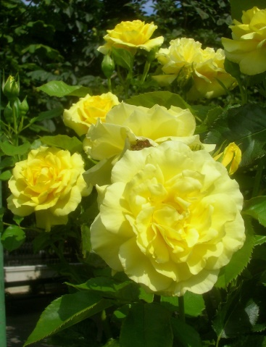

September 11 – Meet the Rose Gardeners
Hudson Gardens
https://www.hudsongardens.org/event/free-meet-the-rose-gardener/

September 21&22 – Colorado Honey Festival
Four Seasons Farmers and Artisans Market, Wheat Ridge
https://www.facebook.com/fourseasonsfam/photos/gm.500859080474393/2422405291378849/?type=3&theater
September 28 – Fall Plant and Bulb Sale
Denver Botanic Gardens
https://www.botanicgardens.org/events/special-events/fall-plant-bulb-sale?fbclid=IwAR2zfIQmifS8YMkQB5vLU7S4GeSGXiWBNz1CEbFTit044m_nxSgBkWpLoaY
October 5&6 – Cider Days Festival
Lakewood Heritage Center, 801 S Yarrow, Lakewood
https://www.lakewood.org/Community-Resources/Arts-and-Culture/Arts-and-Culture-Events/Cider-Days-2019
Plant Sale Supplies
Please, please continue collecting supplies for the Plant Sale:
CARTONS/CONTAINERS - Continue to collect waxed cardboard milk/juice cartons – half gallon and quart. Be sure to rinse them and if possible cut the lid off.
BLINDS - Keep your eyes open for garage or yard sales selling mini-blinds (super cheap and vinyl only, please – we can’t use metal ones). You don’t have to cut them up or clean them.
STICKS - Please collect strong straight sticks – 12-24 inches long for staking the peppers and tomatoes.
Bring any and all to a future FROG meeting or contact Anne to arrange for pick up.

Buttermilk Cornbread Recipe
Since many have asked, here is Lisa Olsen’s yummy cornbread recipe from a recent Garden Tour. ( Adapted by Lisa Olsen from https://www.allrecipes.com/recipe/76594/grandmothers-buttermilk-cornbread/ )

Ingredients:
1/2 cup organic cornmeal (stone-ground
'Floriani Red' heirloom Italian flint
corn; Aspen Moon Farm, Hygiene, CO)
1-1/2 cup all-purpose flour
¾ tsp salt

¾ cup unsalted butter
1 cup granulated sugar
3 large eggs
1-1/2 cup buttermilk
¾ tsp baking soda
1 cup yellow cornmeal

Preheat oven to 400 degrees. Grease a 9"x13" baking pan and line with parchment. In a mixing bowl, melt butter in the microwave; stir in sugar and whisk until smooth. Add eggs and whisk until smooth. Combine buttermilk and baking soda and add to the egg-sugar-butter mixture; whisk until smooth. Stir in cornmeal, flour, and salt and stir until blended (batter will be a little lumpy). Pour batter into prepared pan and place on middle rack of oven. Reduce oven temperature to 375 degrees and bake 30-35 minutes, rotating halfway, until toothpick comes out clean.
To make a savory version, add to the above batter: 3/4 cup grated pepper jack cheese, 3/4 cup creamed corn, 1 seeded and diced jalapeño pepper, 1 seeded and diced Anaheim pepper. These ingredients will add 7-10 minutes to the baking time.

Upcoming FROG Meetings – Generally 4th Tuesday of the Month
October 22 Herbal Insecticides, Donna Shelley
November 26 What’s New for 2020, Harriet from Echter’s
December 10 Holiday Party

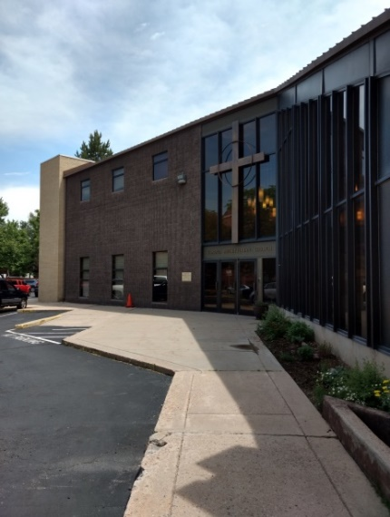
Our Meeting Location
Our monthly Club meetings are being held at Corona Presbyterian Church, 1205 8th Avenue, Denver. The church is at the corner of 8th and Downing, with the entrance facing Downing. There is a parking lot with 36 spaces, including several handicapped and senior spaces, just outside the entrance.
This neighborhood has several one-way streets; Downing is one-way headed north, and 8th is one-way headed west. Suggested routes: For those coming from east or southeast of the church, make your way to 8th Avenue and head west, then turn right onto Downing and another immediate right into the parking area. For those coming from west or northwest of the church, make your way to 6th Avenue, which is one-way headed east, and turn left onto Downing. After you cross 8th Ave, turn right into the parking area. For those coming from south of the church, head north on Downing and after you cross 8th Ave, turn right into the parking area.
For security reasons, the door to the church is kept locked. Trish or Beverly will arrive between 6:30 and 6:45, and monitor the door for arrivals. If you arrive after 7pm, look for a note taped to the glass with a phone number to call, and someone will let you in.

2019 Board Members and Committee Chairs
President: Trish Griffin
Vice President: Rose Ann Bennett,
Treasurer: Marvel Hammer,
Secretary: Suzanne Walter,
Board Members-At-Large:
Gigia Kolouch
Beverly Longe
Linda Tegtmeier
Plant Sale Co-Chairs:
Anne Brinkman
Trish Griffin
Programs:
Betty Jo Page
Rose Ann Bennett
Gigia Kolouch
Grants: Lisa Olsen
Webmaster: Anne Brinkman
Refreshments: Gigia Kolouch
Newsletter Editor: Kim Zeller


Mail your $15 membership check (payable to FROG) and the below information to:
FROG, P.O. Box 112, Englewood, CO 80151-0112.
Your Name ___________________________________________________
Telephone #’s _________________________________________________
Address (Street, City, Zip) _______________________________________
Email Address _________________________________________________
FROG uses email addresses only for club business such as newsletters, updates on events and special announcements. We do not sell, swap, or otherwise share your email address with outside entities. Your contact information, including address, telephone numbers, and email address, will be included on a FROG Membership Roster which will be distributed only to FROG members. If you prefer not to share your contact information on this membership roster, please initial to omit:
address ____ telephone ____ email____.

PLEASE NOTE: Your Submissions are Welcome!
The Deadline for the October Newsletter is:
October 5, 2019.

